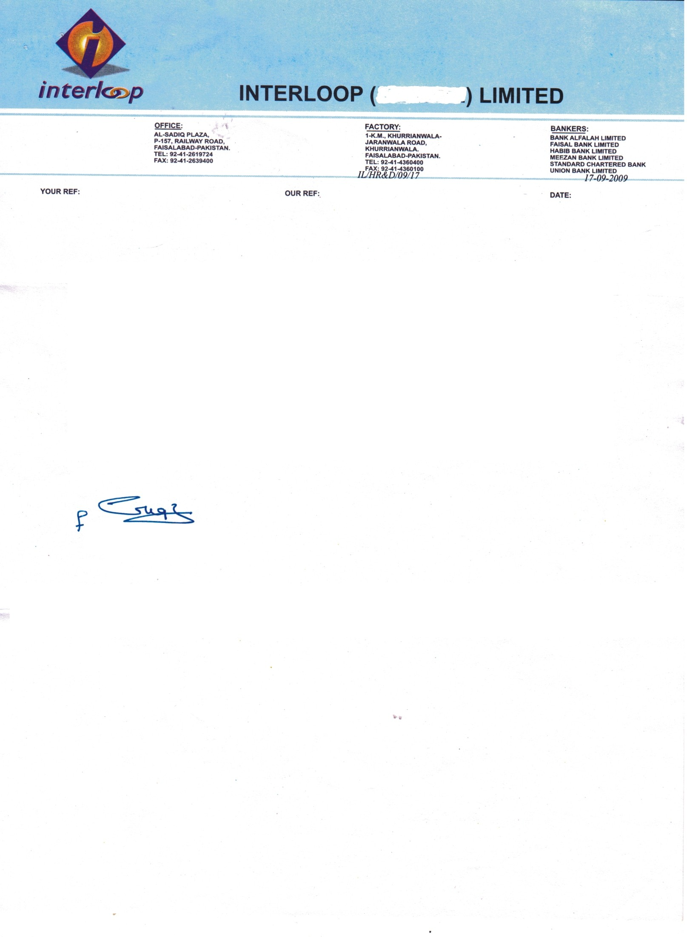

**<To2>**

**TO WHOM IT MAY CONCERN**

It is stated that Mr. <Name> S/O <fname> has worked with us <Designation> from <From2> to <To2>.

This letter has been issued on him upon his own request.



**Mian Naseer Ahmad**

D.G.M HR